 | National University  of Computer and Emerging Sciences  Chiniot-Faisalabad Campus  Department of Artificial Intelligence and Data Science | 
Course Code | AI4002
Course Title | Computer Vision – Lab
Lab Task | 5
Due Date | 17 September 2025
Instructions:
- Rename this Word file as LT5_22F-3170
- If found plagiarism, straight zero will be marked against task.
- Submit task on Due Date. No Late Submission will be Tolerated.

Question 1
Write a Python code that reads the attached 2D Grayscale Image (wheel.png). Use the OpenCV library to extract the edges of that image. Use:
- Sobel Filter (H & V & H+V)
- Prewitt (H & V)
- Scharr (H & V)
- Canny

At the End, the Original Image with these edge detection algorithms, will be shown side by side, like shown in attached sample output.

Hint: Explore https://www.theobjects.com/dragonfly/dfhelp/3-5/Content/05_Image%20Processing/Edge%20Detection%20Filters.htm

Original Image | Sobel (Horizontal) | Sobel (Vertical)
 | 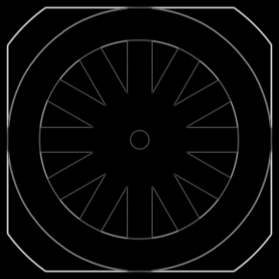
Sobel (H + V) | Prewitt (Horizontal) | Prewitt (Vertical)
 | 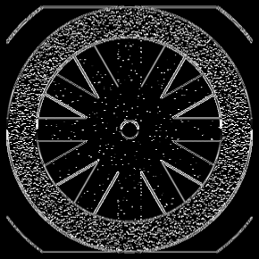 | 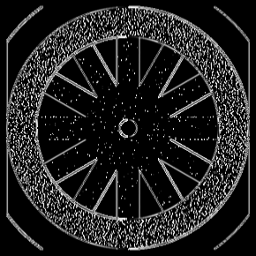
Canny | Scharr (Horizontal) | Scharr (Vertical)
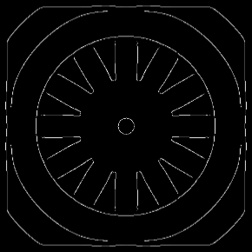 | 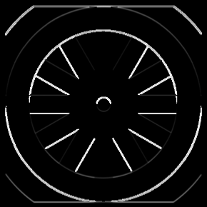 | 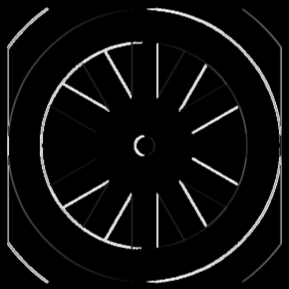

Code
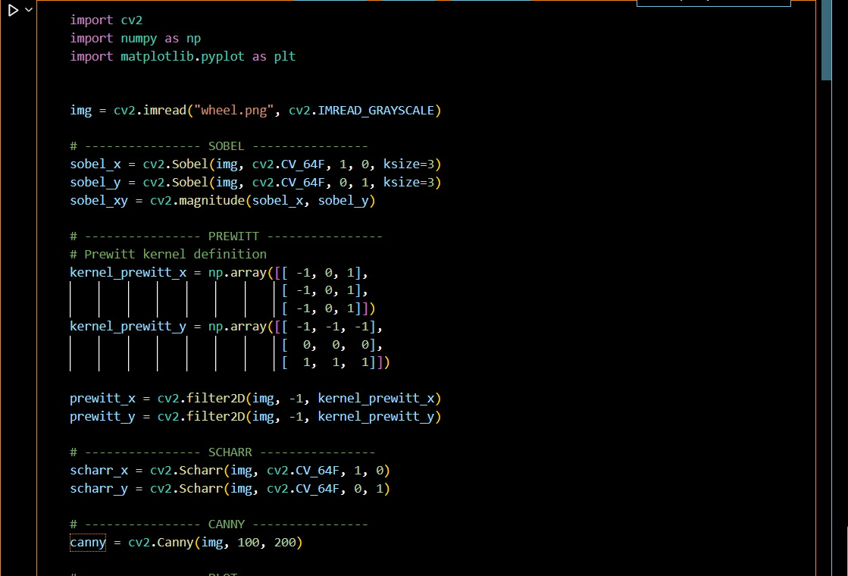

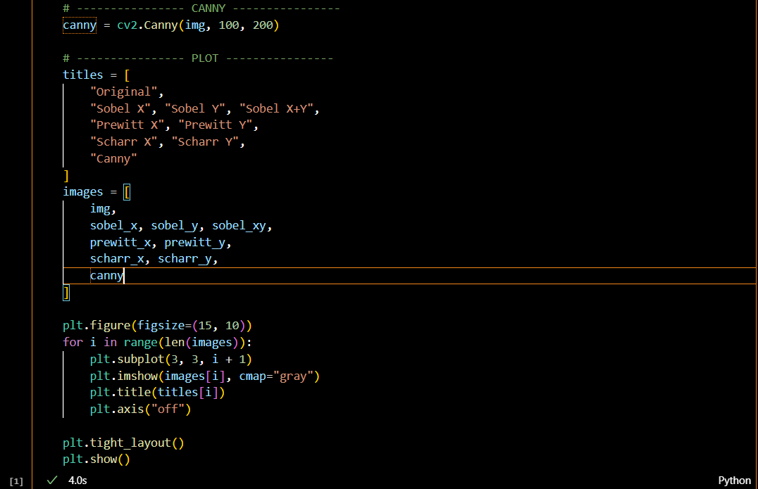
Screenshot
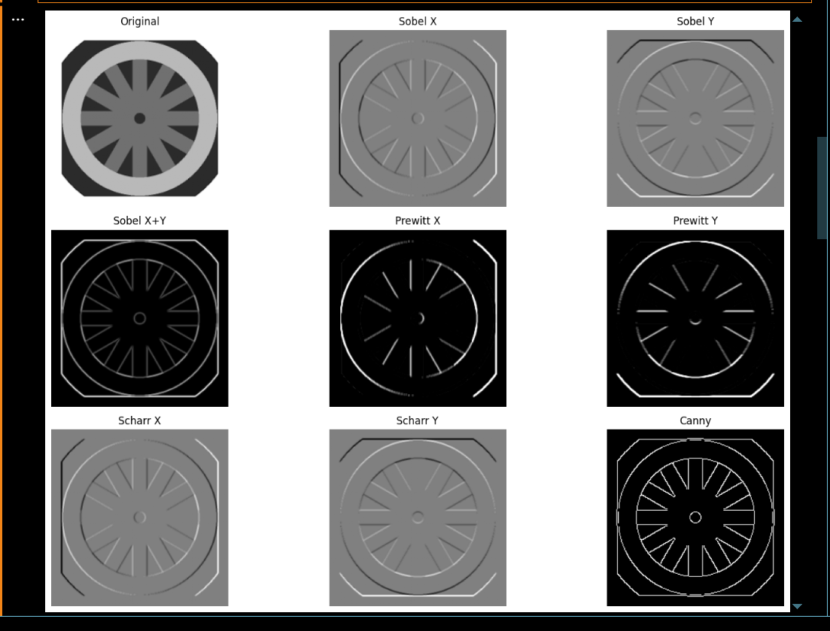

import cv2
import numpy as np
import matplotlib.pyplot as plt

# Image load karein (grayscale mode mein)
img = cv2.imread("wheel.png", cv2.IMREAD_GRAYSCALE)

# ---------- SOBEL ----------
sobel_x = cv2.Sobel(img, cv2.CV_64F, 1, 0, ksize=3)
sobel_y = cv2.Sobel(img, cv2.CV_64F, 0, 1, ksize=3)
sobel_xy = cv2.magnitude(sobel_x, sobel_y)

# ---------- PREWITT ----------
# Prewitt kernel definition manually karni parti hai
kernel_prewitt_x = np.array([[-1, 0, 1],
[-1, 0, 1],
[-1, 0, 1]])

kernel_prewitt_y = np.array([[-1, -1, -1],
[ 0, 0, 0],
[ 1, 1, 1]])

prewitt_x = cv2.filter2D(img, -1, kernel_prewitt_x)
prewitt_y = cv2.filter2D(img, -1, kernel_prewitt_y)

# ---------- SCHARR ----------
scharr_x = cv2.Scharr(img, cv2.CV_64F, 1, 0)
scharr_y = cv2.Scharr(img, cv2.CV_64F, 0, 1)

# ---------- CANNY ----------
canny = cv2.Canny(img, 100, 200)

# ---------- PLOT ----------
titles = [
"Original",
"Sobel X", "Sobel Y", "Sobel X+Y",
"Prewitt X", "Prewitt Y",
"Scharr X", "Scharr Y",
"Canny"
]

images = [
img,
sobel_x, sobel_y, sobel_xy,
prewitt_x, prewitt_y,
scharr_x, scharr_y,
canny
]

plt.figure(figsize=(15, 10))
for i in range(len(images)):
plt.subplot(3, 3, i + 1)
plt.imshow(images[i], cmap="gray")
plt.title(titles[i])
plt.axis("off")

plt.tight_layout()
plt.show()

